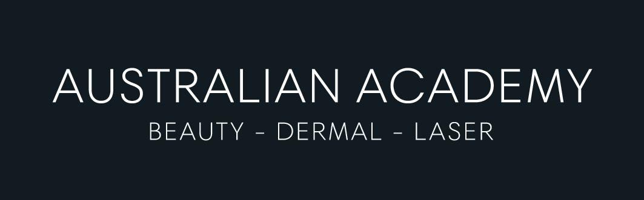

PAYMENT OPTIONS

SHB50115 Diploma of Beauty Therapy
OPTION 1- UTILIZING VET STUDENT LOANS

SHB50115 Diploma of Beauty Therapy | $22,221.00
VET Student Loan available for qualifying students | $16,221.00
Gap fee Student to pay | $ 6,000.00
VET Student Loan available for qualifying students
 | Total $22,221.00

SHB5O115 Diploma of Beauty Therapy
OPTION 2- NOT UTILIZING VET STUDENT LOANS
Student Contribution (Australian Academy interest free loan) | $22,221.00
- I would like to pay weekly | $463.00  (48 payments)
- I would like to pay fortnightly | $926.00  (24 payments)

